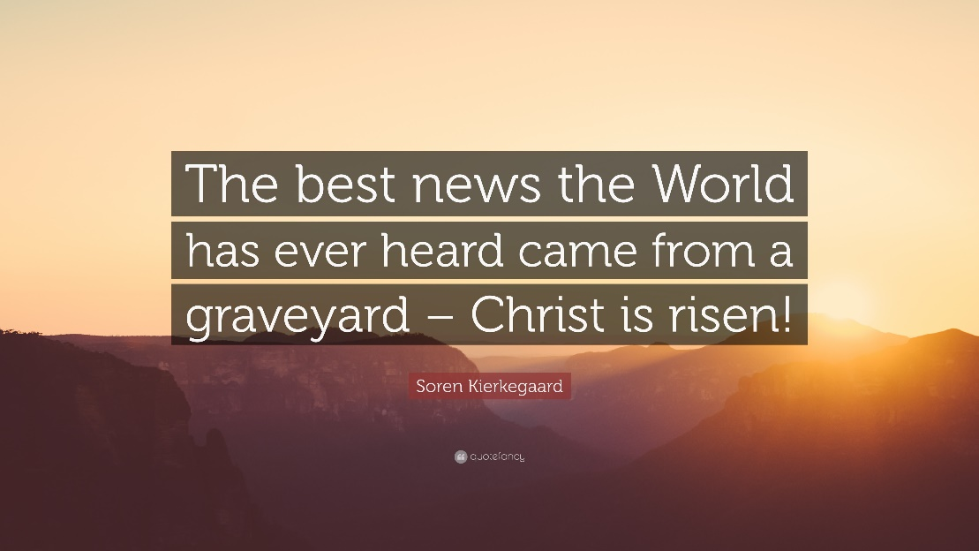

There You Will See Him: In Good News
(A sermon preached via Zoom on April 19, 2020 by Kim Skilling, Anaheim First Presbyterian Church)

Last week we left the women, standing dumbfounded by an empty tomb having first been told by an angel aAnd then by the risen Jesus himself that they were to “Not to be afraid” but that they were to go to the other disciples and the tell them to “Go to Galilee” for "there they would see Jesus." We also remembered how Galilee might be considered code for the place of ordinary life for the disciples. It was their hometown, the place where their friends and family still lived, a place they knew and where they were known, a place where Jesus would go ahead of them--just as Jesus will go ahead of us, into our ordinary lives with all our joys and challenges and there we will meet him. That was the good news entrusted to the women and later, the call to go and tell was extended to all the disciples as well.

Matthew 28:16-20
⁶ Now the eleven disciples went to Galilee, to the mountain to which Jesus had directed them. ¹⁷ When they saw him, they worshiped him; but some doubted. ¹⁸ And Jesus came and said to them, “All authority in heaven and on earth has been given to me. ¹⁹ Go therefore and make disciples of all nations, baptizing them in the name of the Father and of the Son and of the Holy Spirit, ²⁰ and teaching them to obey everything that I have commanded you. And remember, I am with you always, to the end of the age.”

Easter is all about the coming of good, life-giving, life-altering news that the old rules are out the window and a whole new set of rules are in place. Death no longer has the last word. Sin no longer has dominion. No matter how shut off we may feel, no matter how hopeless the situation, we now know that God is in the business of rolling away stones and calling forth new life. That is the news the women were told to Go and tell. That is the news that will allow Jesus’ followers to make disciples, baptize & teach, because Easter wasn’t a one day event that happened roughly 2000 years ago, but is an enduring promise that Jesus will now be with us--always, to the end of the age. Jesus is alive. With us. Going ahead of us. Making a way for us. That is the good news we experience and to which we give witness.

So, today, we celebrate that good news. All of it. The Good News of resurrection AND the signs we see of the continuing gifts of life that we witness each day, popping up all around us—even as we live in isolation or as we venture out to do essential work in spite of personal risk. If we watch, we can see Christ at work in our world in ways that invite us to join him in proclaiming life and hope and new beginnings in the face of the death and fear and uncertainty that confronts us.

So let us now take a few moments to do what the women & disciples were commanded to do and to tell some of the good news we have witnessed. And I am going to kick it off with some personal good news. On Wednesday, my stepson, Tim, and his wife Maggie welcomed their first child into the world.
I am thrilled to introduce you today to Wrenley Rae Ranney, Child of God and my newest grandbaby.
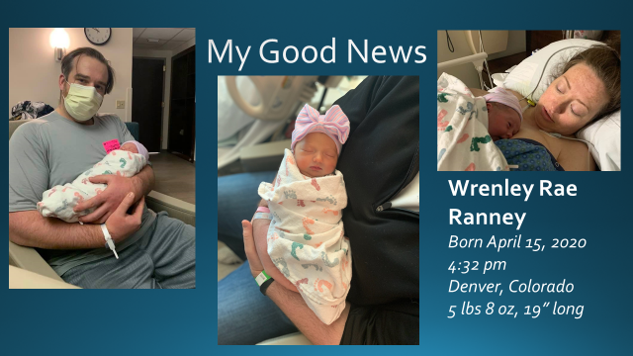
The gift of her precious new life reminds me of the good news of Easter; that our God is a God of life—the creator, redeemer, and sustainer of all life and that is good news that is worth telling!
It also relates to the next bit of good news I want us to highlight this morning. We hear a lot about the number of people who have contracted Covid-19 and know that yesterday was the deadliest day so far for us in Southern California, but we often miss the news of those who are recovering.
One of those victors is the Pastor of Community Presbyterian Church in San Juan Capistrano, the Rev. Leanne Strommen.
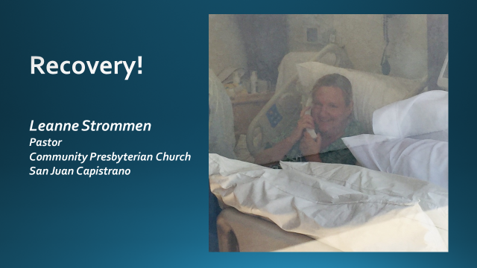
Leanne was critically ill with the virus. She was put on a ventilator with a plan of having her off it for five days so her body could focus all its energy on healing itself. Instead it was over two weeks before she was fully weaned off, but here she is. Smiling at her husband who is standing outside her window and taking this picture. She is now a week out of ICU and hopefully will soon to be transferred to an acute rehab center as the next step to her getting home. And so we celebrate the good news that even Covid-19 doesn’t have the last word the good news of Easter is that the last word always belongs to God.

Which doesn’t mean that every story is a story of victory. Some of our good news stories are stories of costly sacrifice and courage in the face of adversity. People who remind us of Jesus’ statement that “greater love has no one than this, that they lay down their life for another.” It is what Jesus did for us on the cross and, in a sense, it what our medical personnel and first responders do each day as they risk themselves by simply showing up for work. They inspire us with their courage and commitment.
This is Kristen Connor, a PA & Rick and Ginny Connor’s daughter-in-law.

Ordinary Kristen works at an urgent care, but these days she goes wherever she is needed and recently her work brought her into direct contact with the virus. She was sent home to quarantine—not an easy thing to do in a house shared with her husband and three very young children--which also reminds us that the sacrifices being made are not only on the part of the medical workers and first responders, but sacrifices are also being made by their families. Thankfully, her test came back negative for the virus and so we rejoice with the Connor clan in that good news. However, her clear report means that she is back at work on the front lines, doing what she is called to do. The good news of Easter is not that Jesus promises to keep us safe, but that we will be given the strength we need to answer our call. And so we give thanks and pray for all those who put themselves in harm’s way to ensure the health and safety of the rest of us.

Then there are those who are rising to the occasion and meeting challenges that they never signed up for. For example, there is David. He is the son of one of our members and a math teacher in one of the poorer neighborhoods of Orange County. When schools went to distance learning he was instructed that his role during this time was not to try and teach new material, but to review previously taught math with his students and answer any questions they might have. However, what he actually finds himself doing most of the time is providing emotional support to his students. His kids are really scared and ask him a lot of questions about COVID-19 so this dedicated teacher is helping them deal with their fear & anxiety as best he can, offering instruction in deep breathing & other relaxation strategies. He even did a lesson on “Flattening the Curve” incorporating math strategies while sneaking in some important information on COVID-19. Even though his subject is math, he encourages students to keep up with their reading and even gave them some examples of books he is currently reading like “Spider Man”. These kids already have multiple stressors in their lives related to their poverty. They often don’t know from where their next meal will come and many live in over-crowded homes that are not always safe, so having this new & added stress of COVID-19 has been completely overwhelming for many of them. But the good news is, they also have their teacher, David, who not only offers them fundamental math skills, he is seeking to help them develop essential life skills and to offer them stability and a sense of safety in a tumultuous time.

But we know that the teachers aren’t the only ones who have had to adapt. Parents find themselves in a strange new world where they must homeschool their kids while simultaneously attending to their jobs. For parents whose work still takes them outside the home, safe child care has become a critical issue. For those now working from home, balancing work and child care is a ongoing challenge. But the good news is that many families are creatively rising to the occasion. Emily and Jerry Fuentes trade off during the day, taking shifts with the kids in order to allow the other parent to work. One thing they have tried to weave into each day is a “social distancing adventure.” Last week that took them to the playground at Tustin Presbyterian Church where Emily works as Director of Youth. They sanitized it ahead of time so the girls could get outside, play and run off some energy. And this reaction gave them a great idea. https://www.facebook.com/emily.fuentes.50/videos/pcb.995086518249/995085954379/?type=3&theater (Video may not be available to everyone due to privacy settings, but it is a video of the girls being asked if they would like to play in the playground “with no germs” and Jade running forward crying “Yaaay!”)
What if they offered to sanitize our church’s playground for any of our families whose kids also might need to get out and get active in a safe environment? And so part of the good news we have to tell today is that is exactly what they plan to do. Hopefully, this week they will have worked out a system and we will be letting our families know how to take advantage of this option.

We could keep going. One thing that I have noticed is that when you start identifying and naming good news you just keep finding more examples. There is way more good news to share than we have time to tell today! However, as I have reflected on the good news stories we have named today and the many others that surround us, they all seem to have something in common. They all remind us that we are not alone. The promise is that the risen Lord goes before us and there we will meet him—often in and through each other.

A recent show by James Corden served as a reminder of this truth to Tracy Ramont. So I would invite Tracy to say a few words about the good news she heard at the close of this show. Tracy?

[Tracy spoke to how she was encouraged by this reminder of our call to be there for each other and how it helped her get past her own sense of discouragement that day]

https://www.youtube.com/watch?v=_10msPMEick

NOTE: After James Corden’s remarks we paused the video for these concluding words:
James Corden chose to end his show with the song, “You are Not Alone” and that seems to be a good way for us to close our Reporting of Good News as well. As you listen to the song, I would invite you to think about the ways that you have been found by God and others in this time and to give thanks for that good news. I would also encourage you to think about those you know who may feel lost and pray about how you can communicate to them the good news through word or action, that they are not alone, that we are always found in God.

